Instructions for displaying BrokerCheck Widget

**Step 1:**

Include ([**http://aws-cdn.finra.org/widgets/bcw/css/style.min.css**](http://aws-cdn.finra.org/widgets/bcw/css/style.min.css)) file in the <head> section of the document as shown in the example below:

<head>

<title>Broker Check Widget</title>

<meta http-equiv="X-UA-Compatible" content="IE=Edge" />

<meta name="viewport" content="width=device-width, initial-scale=1.0">

<link type="text/css" rel="stylesheet" href="<http://aws-cdn.finra.org/widgets/bcw/css/style.min.css>">

</head>

**Step 2:**

Include ([**http://aws-cdn.finra.org/widgets/bcw/js/jquery.finra.static.min.js**](http://aws-cdn.finra.org/widgets/bcw/js/jquery.finra.static.min.js)) and ([http://aws-cdn.finra.org/widgets/bcw/js/**jquery.finra.bcwidget.min.js**](http://aws-cdn.finra.org/widgets/bcw/js/jquery.finra.bcwidget.min.js)) files just before the end of body tag as shown in the example below. Also include the function call shown below in yellow highlight.

<script src="http://aws-cdn.finra.org/widgets/bcw/js/jquery.finra.static.min.js" type="text/javascript"></script>

<script type="text/javascript">var j171 = jQuery.noConflict();</script>

<script src="http://aws-cdn.finra.org/widgets/bcw/js/jquery.finra.bcwidget.min.js" type="text/javascript"></script>

<script>

(function( j171 ) {

j171(".add-finra-bc-widget").BCWidget();

})( jQuery );

</script>

</body> //end of body tag

**Step 3:**

Placement of Widget: Include the following DIV structure in the section of the page where the BrokerCheck Widget needs to be displayed (ideally in right or left column).

<div class="bcwidgetCover">

<div class="add-finra-bc-widget"></div>

</div>

Note: The broker check widget takes the width of the container DIV. The width of the container can go up to a maximum width of 480px, however it is expected to be at least 370px. Since the placement of logo and background gradient is designed for 370px, there would be some CSS updates required if the container width is between 370px and 480px.

The rendered BrokerCheck Widget will look like this:

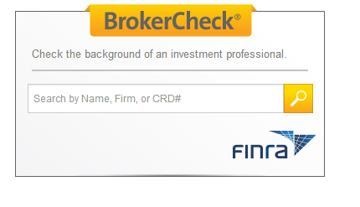

Type few characters to see the dropdown displayed below:

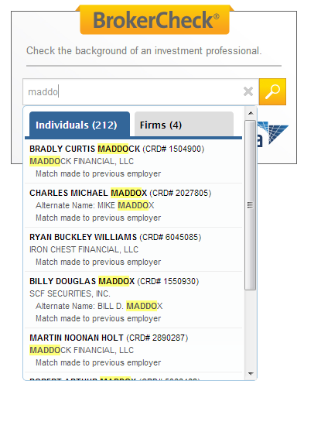

Select an item from the dropdown to see the results screen displayed below:

